Decrypt an encrypted message

Project Overview
This project involves using Linux Bash shell commands to explore a file system, locate a hidden file, decrypt a Caesar cipher, and recover an encrypted file to reveal a hidden message. The scenario simulates a situation where all files in the home directory (/home/analyst) have been encrypted, and the objective is to decrypt them systematically to retrieve critical data.
The project is divided into three main tasks:
- Exploring the home directory and reading instructions from a file.
- Locating a hidden file and decrypting its Caesar cipher to obtain a decryption command.
- Using the revealed command to decrypt an encrypted file and recover its contents.
Objectives
- Gain practical experience with basic Linux commands (ls, cat, cd).
- Understand how to identify and access hidden files in Linux.
- Learn to decrypt a Caesar cipher using the tr command.
- Apply the openssl command to decrypt an AES-256-CBC encrypted file.
- Develop problem-solving skills in a Linux terminal environment.

Project Tasks

Task 1: Explore Directory and Read Instructions
Objective: List the contents of the home directory (/home/analyst) and read the README.txt file to obtain further instructions.
- Steps:
  - Use the ls command to list files in the current working directory.
    - Expected output: Q1.encrypted README.txt caesar
  - Use the cat command to display the contents of README.txt.
    - The file indicates that the caesar subdirectory contains a hidden file with further instructions.
- Purpose: Familiarize with navigating and inspecting a Linux directory structure.
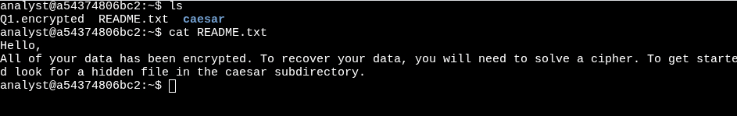
Hello,
All of your data has been encrypted. To recover your data, you will need to solve a cipher. To get started look for a hidden file in the caesar subdirectory.

Task 2: Locate and Decrypt Hidden File
Objective: Navigate to the caesar subdirectory, find a hidden file, and decrypt its Caesar cipher to reveal a command needed for the next task.
- Steps:
  - Change to the caesar subdirectory using cd caesar.
  - List all files, including hidden ones, using ls -a.
    - Expected output: . .. .leftShift3
  - Display the contents of the hidden file .leftShift3 using cat .leftShift3.
    - The contents are encrypted with a Caesar cipher (shifted three letters to the left).
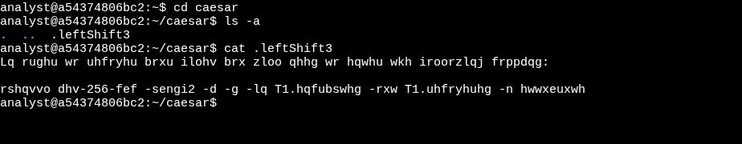
  - Decrypt the cipher using the command:
cat .leftShift3 | tr "d-za-cD-ZA-C" "a-zA-Z"
  - Return to the home directory using cd ~.
- Purpose: Learn to identify hidden files and decrypt a Caesar cipher using character translation.
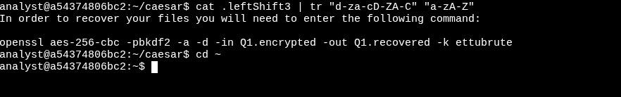
In order to recover your files you will need to enter the following command:

openssl aes-256-cbc -pbkdf2 -a -d -in Q1.encrypted -out Q1.recovered -k ettubrute

Task 3: Decrypt the Encrypted File
Objective: Use the command revealed in Task 2 to decrypt the Q1.encrypted file and read the recovered message.
- Steps:
  - Execute the decryption command:
openssl aes-256-cbc -pbkdf2 -a -d -in Q1.encrypted -out Q1.recovered -k ettubrute
    - This uses AES-256-CBC to decrypt the file with the password ettubrute, outputting the result to Q1.recovered.
  - List the directory contents using ls to confirm the creation of Q1.recovered.
    - Expected output: Q1.encrypted Q1.recovered README.txt caesar
    - Display the contents of the decrypted file using cat Q1.recovered to reveal the hidden message.
- Purpose: Apply a complex decryption command and verify the recovery of data.
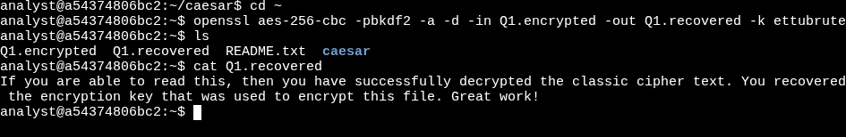
If you are able to read this, then you have successfully decrypted the classic cipher text. You recovered the encryption key that was used to encrypt this file. Great work!

Project Summary:
As a security analyst, I tackled a Linux exercise to decrypt files in /home/analyst, mimicking real-world incident response. I explored the directory, checked README.txt for clues, and moved to the caesar subdirectory. There, I found the hidden .leftShift3 file and cracked its Caesar cipher, revealing an OpenSSL command. Back in the home directory, I decrypted Q1.encrypted to create Q1.recovered, uncovering a hidden message, likely a confidential note.
This felt like a real investigation, with hidden files similar to forensic evidence. The Caesar cipher showed how even basic encryption can challenge systems. Using OpenSSL for decryption was like tackling real data recovery. Accuracy was key; one slip could stop everything, just like in real cases. This activity helped me gain knowledge in Linux and cryptography, highlighting their role in data security.

